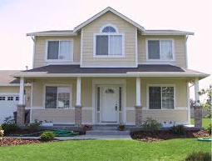A

ERAS

**NIGERIA LIMITED**

CIVIL & MECHANICAL SERVICES

|  |  |  |  |  |  |
| --- | --- | --- | --- | --- | --- |
|  |  |  |  |  |  |

1st March, 2022

The State Co-ordinator

N.Y.S.C Secretariat

Abeokuta

Ogun State.

Through,

The local Government Inspector,

Agbara Zone.

**MONTHLY CLEARANCE: CORPER AARE MARIAM ODUNAYO BATCH A NYSC/UIB/2021/096658**

This is to certify that Corper Aare Mariam Odunayo a Batch A NYSC/UIB/2021/096658 with the State Code OG/21A/6273 deployed to undergo her mandatory one- year Youth service corps Assignment at **ERAS NIGERIA LIMITED** has performed her allocated duties satisfactorily in the month of March 2022.

Thanks.

Yours faithfully,

………………………….

**For: Eras Nig Ltd**

**08033895356**

Office Address: 5, Adenubi Close Off Toyin Str, Ikeja, Lagos State.

Tel: 08033895356 Email: lekside99yahoo.co.uk

